Project Development Phase
Model Performance Test

Date | 10 February 2025
Team ID | LTVIP2025TMID25057
Project Name | CRM APPLICATION FOR JEWEL MANAGEMENT
Maximum Marks

Model Performance Testing:
Project team shall fill the following information in the model performance testing template.
S.No. | Parameter | Values | Screenshot
 | Model Summary | -
 | Accuracy | Training Accuracy -  Validation Accuracy - | 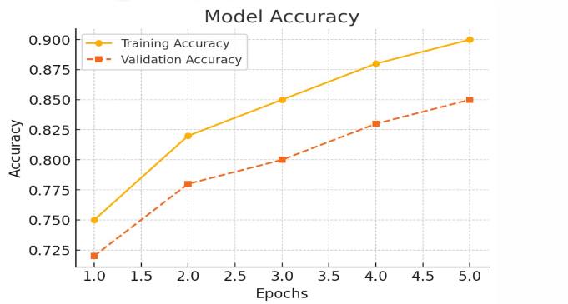
3. | Fine Tunning Result( if Done) | Validation Accuracy - | 